Capstone Project Proposal

Company Target: CARFAX Canada
Product Name: VoltAI – EV Battery Health & Life Intelligence Platform
Proposed By: Nagham Murad, Heba Alsharif
Department of Artificial Intelligence and Machine Learning/ Fanshawe College
Course: Capstone / Project-Based Machine Learning
Instructor: Professor Magdalene Ravichandran
Semester: 2025–2026

1. Executive Summary
As electric vehicles expand in both new and used markets, battery health has become a critical yet opaque factor affecting vehicle value, reliability, and consumer confidence. Buyers of used EVs face uncertainty due to lack of accessible battery information, which impacts trust, pricing, and purchase decisions.
VoltAI is an AI-powered, explainable battery intelligence platform designed to enhance EV vehicle history reporting for CARFAX. VoltAI predicts State of Health (SOH) and Remaining Useful Life (RUL) using partial usage and driving data reflective of real-world EV usage. Developed as a proof-of-concept using Agile principles, VoltAI delivers early, interpretable insights that are adaptable to stakeholder feedback and empirical evaluation.
By integrating VoltAI into CARFAX reports, the company can increase transparency, strengthen consumer trust, and differentiate its EV reporting services, addressing a growing industry need.

2. The Big Idea
CARFAX provides trusted vehicle history reporting, translating complex data into actionable insights. With EV adoption, a key gap has emerged: battery health is not visible or interpretable. VoltAI addresses this by translating complex degradation patterns into intuitive indicators for consumers and dealers, supporting CARFAX’s mission of transparency and informed decision-making.

3. Problem Statement
EV batteries degrade over time due to driving behavior, charging patterns, environmental exposure, and aging. However, battery health is difficult to assess for vehicle history providers due to proprietary sensor data and the lack of standard reporting. Current solutions are manufacturer-specific, technical, or rely on black-box predictions with low interpretability, limiting buyer confidence and reducing the value of used EV reports.

4. Product Description
VoltAI predicts EV battery SOH and RUL using partial usage data (mileage, charging frequency, driving behavior, and time-based degradation). The system combines predictive machine learning with explainable AI to communicate both outcomes and the factors driving predictions.
VoltAI is modular and research-focused, capable of integration into CARFAX reports using health scores, confidence ranges, or risk indicators that are intuitive for end-users.

5. Market Opportunity and Need
The used EV market is rapidly growing, yet battery uncertainty is a key barrier to adoption. Battery replacement costs can reach several thousand dollars, making health a critical factor in resale and buyer confidence.
VoltAI allows CARFAX to:
- Increase transparency in used EV listings
- Reduce buyer uncertainty and perceived risk
- Differentiate EV history reports from competitors
- Strengthen long-term consumer trust
The system works without relying on proprietary sensor-level data, supporting scalable adoption.

6. Competitive Landscape
Current approaches:
- Manufacturer diagnostics (limited access)
- Mileage- or age-based estimation (low precision)
- Black-box ML models (poor interpretability)
VoltAI differentiates by:
- Using data compatible with vehicle history platforms
- Prioritizing explainable and transparent outputs
- Delivering reporting-level insights, not low-level diagnostics

7. Agile Development Approach
VoltAI will follow Agile, iterative principles:
- Short iterations: Frequent updates to deliver measurable outcomes
- Empirical decisions: Model performance and explainability guide refinements
- Stakeholder collaboration: Feedback aligns development with CARFAX reporting needs
- Adaptability: System evolves as new data or requirements arise
Sprint Breakdown
Sprint | Duration | Goal / Deliverable | Notes
1 | 2 weeks | Data collection, cleaning, feature engineering | Baseline dataset ready
2 | 2 weeks | Train baseline models (Linear Regression, SVR) | Initial SOH/RUL predictions
3 | 2 weeks | Develop advanced models (LSTM, XGBoost) | Temporal and feature-based predictions
4 | 1 week | Apply SHAP explainability, analyze key degradation factors | Human-readable insights
5 | 1 week | Integrate reporting mock-up | Conceptual CARFAX dashboard/outputs
6 | 1 week | Testing, evaluation, final refinement | MAE, RMSE, R² metrics validated

8. Team Roles
- Nagham Murad: Data preprocessing, baseline and advanced model development, explainability analysis
- Heba Alsharif: Feature engineering, methodology design, evaluation metrics, report preparation
- Collaborative Tasks: Sprint planning, Agile coordination, presentation materials, documentation

9. Research Objectives
- Predict EV battery SOH and RUL using partial usage data
- Compare temporal vs. feature-based modeling approaches
- Apply explainable AI to highlight key degradation factors
- Demonstrate actionable reporting for CARFAX-style vehicle history

10. Methodology and System Architecture
10.1 Methodology
The VoltAI system follows a structured machine learning pipeline:
Data Preparation
- Cleaning and normalization of battery cycle data
- Computation of SoH and RUL
- Feature selection (voltage, temperature)
Modeling Approaches
- Baseline: Linear Regression
- Feature-Based Models: Random Forest, XGBoost, Support Vector Regression (SVR – Tuned)
- Temporal Model: LSTM
- Final Selected Model: Tuned Support Vector Regression (SVR)
Explainability
- SHAP analysis for feature importance
- Evaluation
- RMSE
- R²
Experimental evaluation shows that tuned SVR achieves superior predictive performance compared to both exponential degradation models and deep learning-based approaches for the NASA dataset.

10.2 System Architecture
To provide a structured overview of VoltAI’s implementation, the system architecture is divided into five logical layers: Data Layer, Feature Engineering Layer, Modeling Layer, Evaluation Layer, and Application Layer. Each layer represents a critical stage in transforming raw battery cycle data into actionable, explainable EV battery intelligence.
1. Data Layer
The Data Layer represents the foundation of VoltAI. The system utilizes the publicly available lithium-ion battery degradation dataset provided by NASA.
This dataset contains cycle-level battery information, including:
- Cycle number
- Voltage
- Temperature
- Capacity
The dataset simulates real-world degradation patterns under controlled experimental conditions. It serves as a research proxy for EV battery usage behavior in the absence of proprietary manufacturer sensor data.
This layer is responsible solely for structured data ingestion into the modeling environment.

2. Feature Engineering and Preprocessing Layer
This layer transforms raw battery measurements into meaningful predictive variables.
State of Health (SoH) Computation
SoH is calculated as:
SoH = Current Capacity / Initial Capacity
This provides a normalized degradation indicator between 0 and 1.
Remaining Useful Life (RUL) Computation
RUL is defined as:
RUL = Maximum Cycle − Current Cycle
This represents the estimated number of cycles remaining before end-of-life.
Feature Selection
Key input features include:
- Voltage
- Temperature
These variables are selected due to their direct relationship with battery degradation dynamics.
Scaling
MinMax normalization is applied to:
- Input features (for both models)
- Target variables (for LSTM training)
This ensures numerical stability and improves convergence during model training.

3. Modeling Layer
The Modeling Layer contains two complementary predictive approaches to compare feature-based and temporal learning.

A. Feature-Based Modeling – Random Forest
A RandomForestRegressor is implemented to model nonlinear relationships between voltage, temperature, and degradation.
Characteristics:
- Captures complex feature interactions
- Robust to noise
- Requires no temporal sequencing
Outputs:
- Predicted SoH
- Predicted RUL
This model represents a scalable approach suitable for structured vehicle history datasets.

B. Temporal Modeling – LSTM Neural Network
A Long Short-Term Memory (LSTM) neural network is implemented to capture sequential degradation patterns.
Architecture:
- Sequence length: 10 cycles
- LSTM layer (50 units)
- Dropout (0.2)
- Dense output layer
The LSTM learns time-dependent degradation trends that traditional feature-based models may overlook.
Outputs:
- Predicted SoH
- Predicted RUL
This model represents a deep learning approach capable of modeling battery aging behavior over time.

4. Evaluation Layer
The Evaluation Layer measures predictive performance and compares modeling approaches.
Performance metrics include:
- Root Mean Squared Error (RMSE)
- R² Score
Model evaluation is performed on both training and testing datasets to assess:
- Predictive accuracy
- Generalization performance
- Potential overfitting
Additionally, visualizations such as:
- Predicted vs. Actual plots
- Training vs. Validation loss curves
are used to analyze model stability and convergence behavior.

5. Application and Reporting Layer (VoltAI Output)
The final layer translates model predictions into actionable outputs aligned with CARFAX-style reporting.
VoltAI generates:
- Predicted State of Health (SoH)
- Predicted Remaining Useful Life (RUL)
- Degradation trends
These outputs can be formatted into:
- Health score indicators
- Risk levels
- Confidence ranges
This layer bridges machine learning research and consumer-facing vehicle history reporting, demonstrating how predictive battery intelligence can enhance EV transparency and buyer confidence.

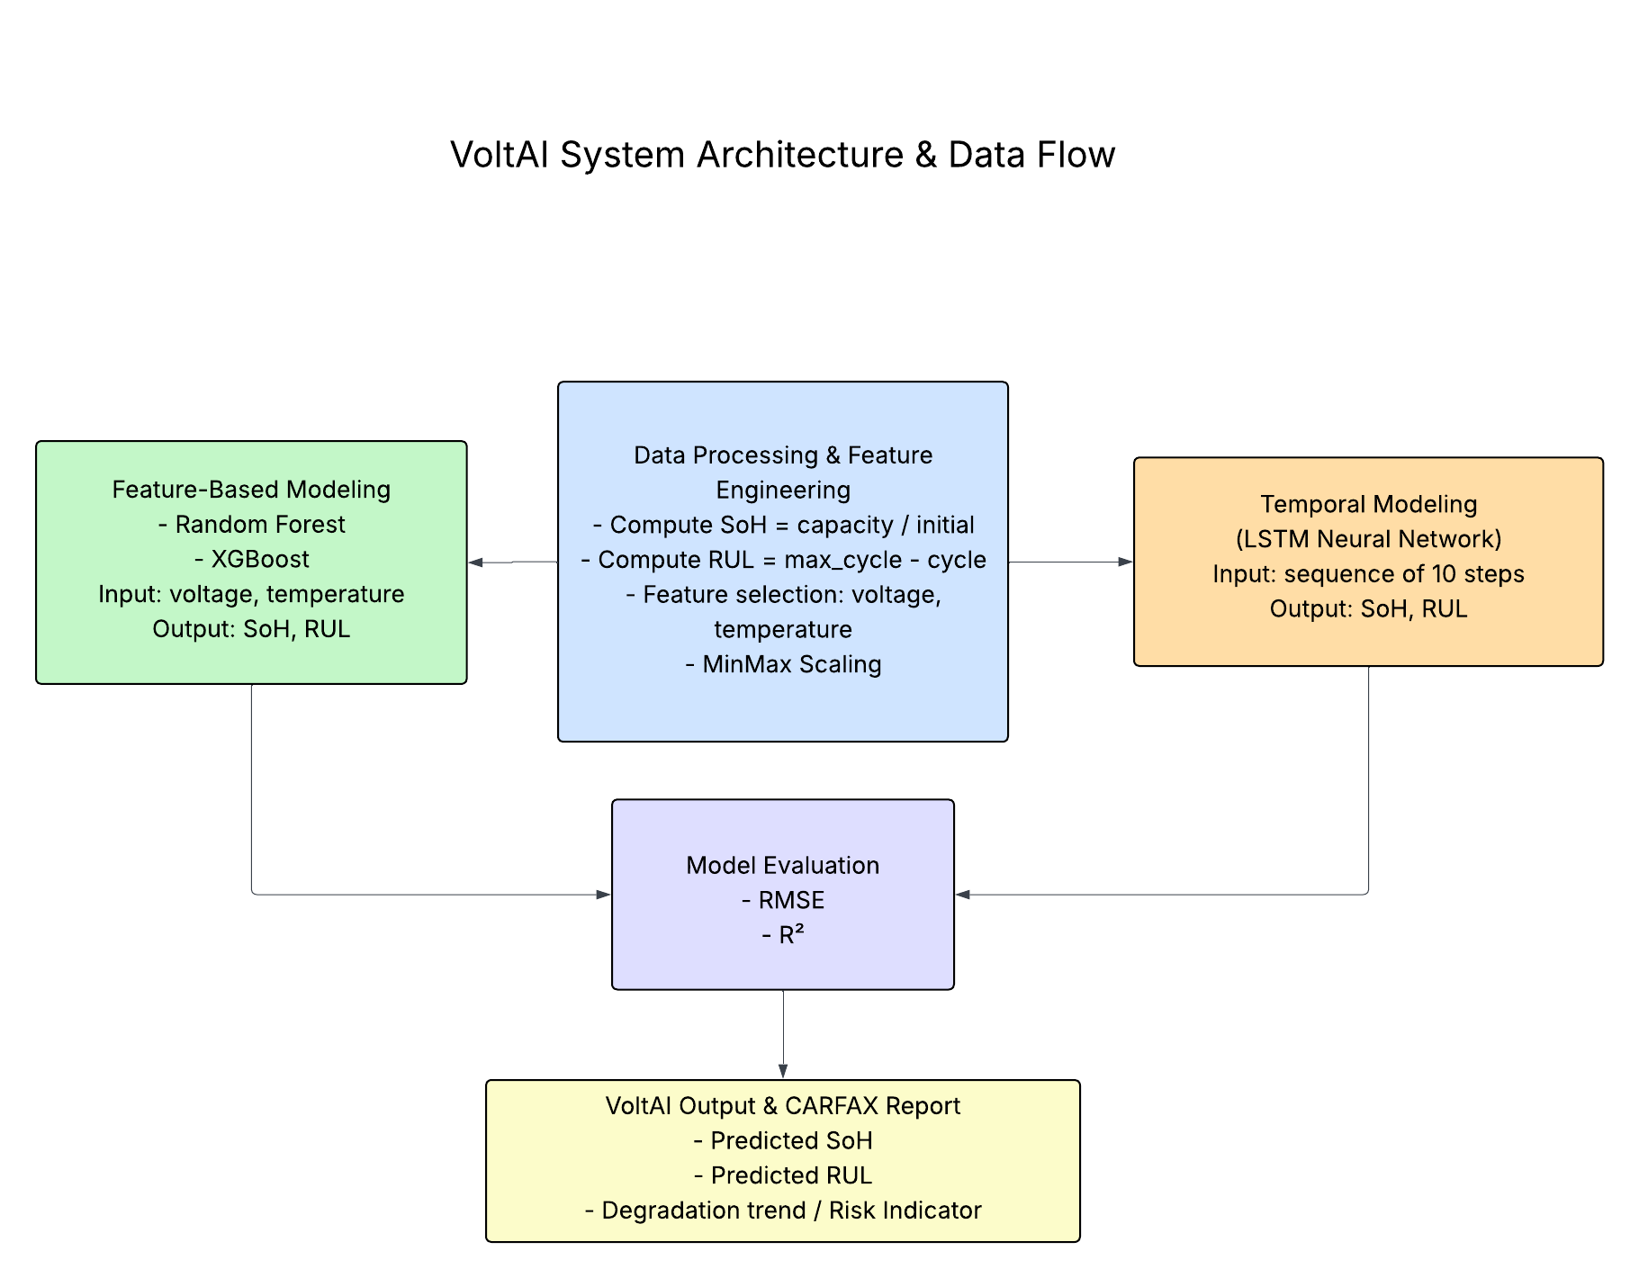
11. Expected Outcomes
- Functional proof-of-concept predicting EV battery health and life
- Explainable insights for non-technical users
- Identification of influential usage patterns
- Demonstrated applicability for CARFAX-style vehicle history reports

12. Significance to CARFAX
VoltAI strengthens CARFAX’s mission by adding battery transparency to EV reports, improving consumer confidence, reducing purchase risk, and positioning CARFAX as a leader in used EV reporting. The platform is scalable, interpretable, and aligned with real-world data availability.

13. Conclusion
VoltAI is an Agile-developed, explainable AI solution for EV battery health and life prediction. It bridges the gap between advanced ML research and practical, consumer-facing vehicle history reporting, providing CARFAX with actionable, transparent insights for the growing EV market.

